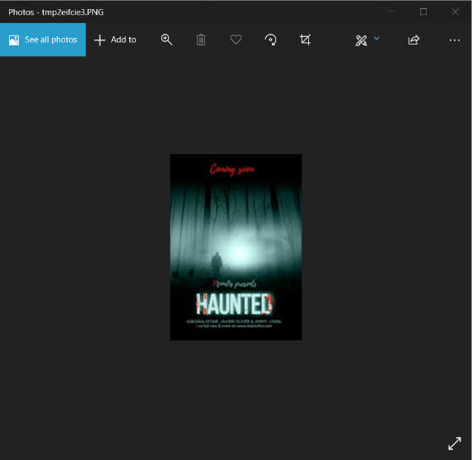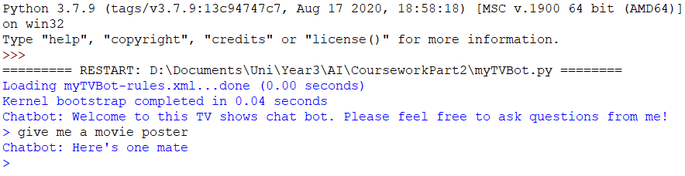

Rule based component using AIML rules. Randomly selects an image from sample images folder

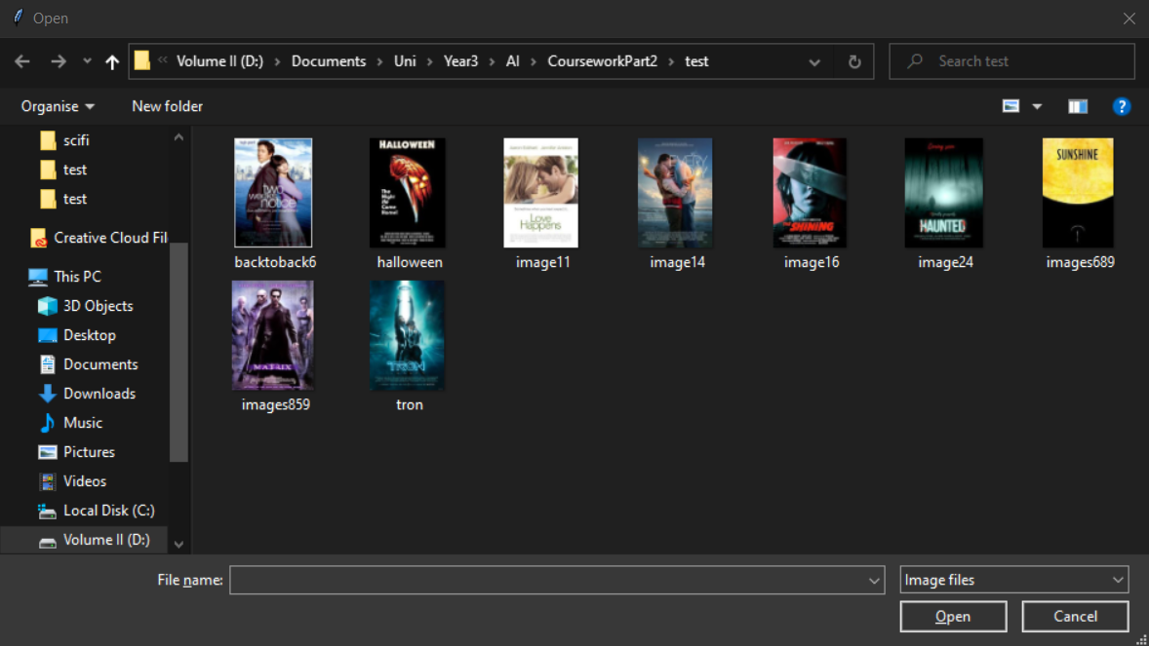

Rule based component using AIML rules. Opens file dialog box allowing user to select an image from sample images folder.



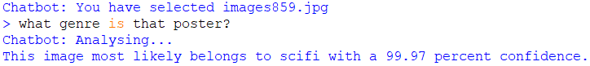

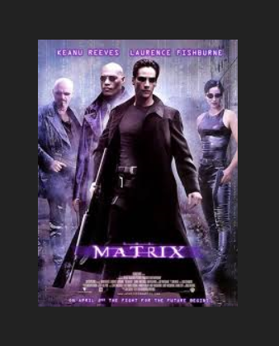

Rule based component using AIML rules. Chatbot uses the selected poster and the model to predict the class. Here it correctly predicts The Matrix to be a sci-fi movie with 99.97% confidence.